Introduction:
Hello and it’s nice to meet you! Thank you so much for taking the time to consider us as part of your life and adoption plan. We believe, this is the part of the story where your page meets ours. We cannot imagine what you are going through and how scary this must seem. We hope that you know, we are beyond excited to meet you and admire your strength more than words could possibly describe. We hope to provide an amazing life for your baby, filled with love, support, and lots of laughter. We cannot say we will be perfect parents, but we can promise, we will always provide unconditional love. This will be our first child and we cannot wait to become parents! We both have large families who are thrilled about the idea of adding a new addition to our family! We hope to learn all about you so that we can understand and implement what is important to you and for the baby. We hope to teach the baby about your values and cultural traditions, along with our own! Thank you again for taking the time to learn about us! You are our hero... Having a baby would be the greatest gift anyone could ever give. Thank you from the bottom of our hearts.

Love,
Brianna + Daniel

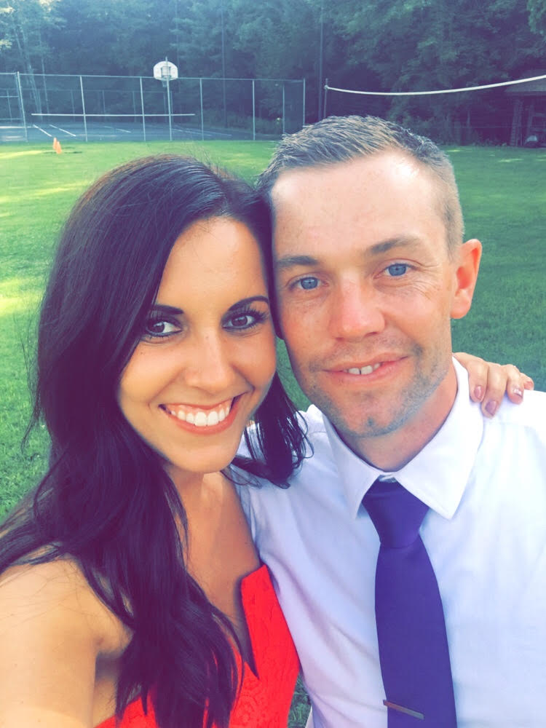

Our Story:
We met through mutual friends many years ago when we were teenagers at a country music concert. We came from two totally different worlds as Dan grew up on a farm and Bri, from the suburbs. Even though we had different backgrounds, we had many similarities such as our faith and passion for wanting to make the world a better place. We remained just friends until 2013 when Dan finally asked Bri on a date! Since that first date, we have been inseparable. Dan proposed only after 6 months of dating and we were married the following year, in 2014. We instantly became a family of 3... Dan, Bri and our dog, Boone. Dan rescued Boone from a shelter 10 years ago and have been best buds ever since. We love each other more with each day that passes and believe a good relationship stems from open communication and constant support. We are each other’s best friends and do everything together. We have worked really hard over the years in order to build a future together. We have wanted to become parents for as long as we can remember and are beyond excited for our greatest adventure yet. Brianna knew since she was in her early 20s that she could never become pregnant with biological children. For years, we attempted infertility treatment but had no success. One day we looked at each other and said, what are we doing? And, felt as though Jesus was speaking to us. He told us that he had a bigger plan in store for us through adoption. Adoption was something was something that was always in our hearts and we knew it was time to follow the lord’s plan. Adoption is such a beautiful process and we cannot wait to meet you and learn about our future child!
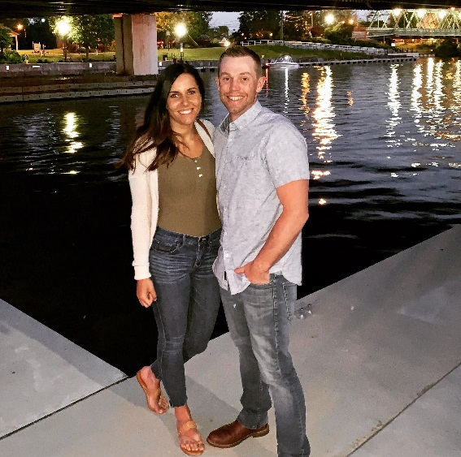
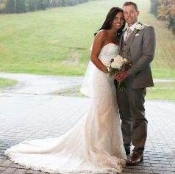

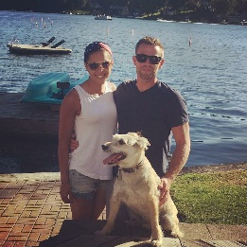
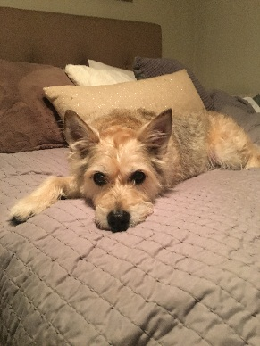

Meet Brianna:
Hi there! I am a 30 year old pediatric nurse and am so full of life. I wear my heart of my sleeve and am a caregiver by nature. I work as a school nurse in a Hispanic/Urban School in the city and feel as though I have the best job in the world! I am pretty fluent in Spanish and English. In my free time, I enjoy organizing events to benefit my students and their families. My school primarily serves refugees who fled their countries of origin due to natural disaster and other hardships. I feel so humbled and blessed with all god has provided me, and I try to give back as much as possible. Dan and I also serve Dove Missions which is an organization that provides education and healthcare to orphans in the Dominican Republic. Some of our most treasured memories are those spent in the Dominican with our little kiddos. Outside of work, I enjoy spending time with my husband, our dog Boone, and my family! I enjoy being active and spending time outdoors as much as I can! I am very soft spoken, open minded, gentle and patient. I love to have fun and it does not take much to make me happy! I believe it’s the simple things in life that make all the difference. I am driven by love and truly believe kindness is contagious. I cannot wait to be a mom and encourage my child to reach for the stars and be all they want to be.
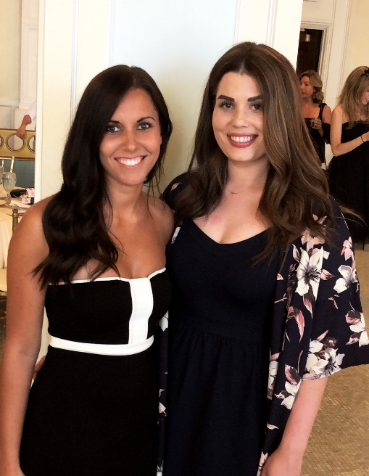
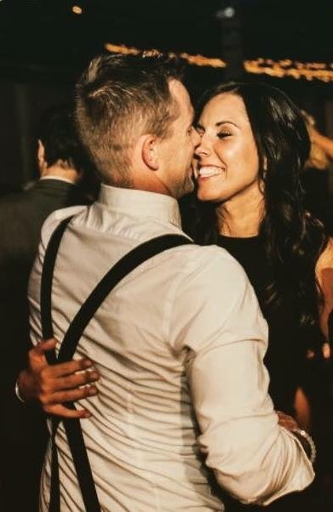
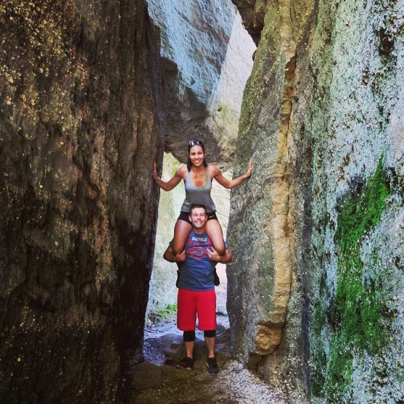

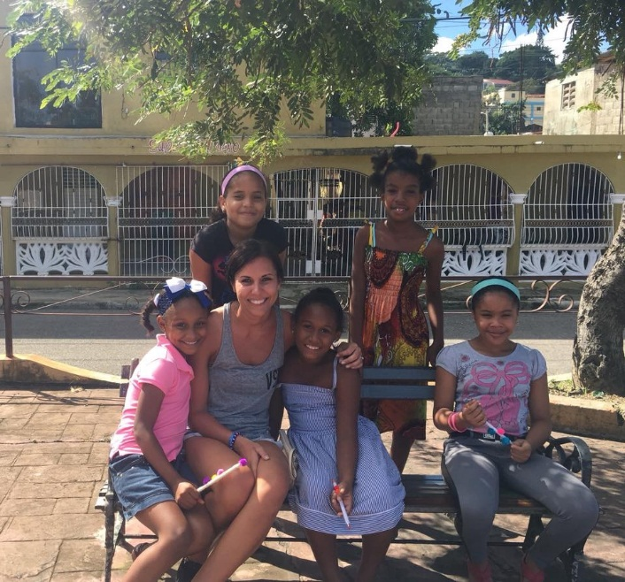

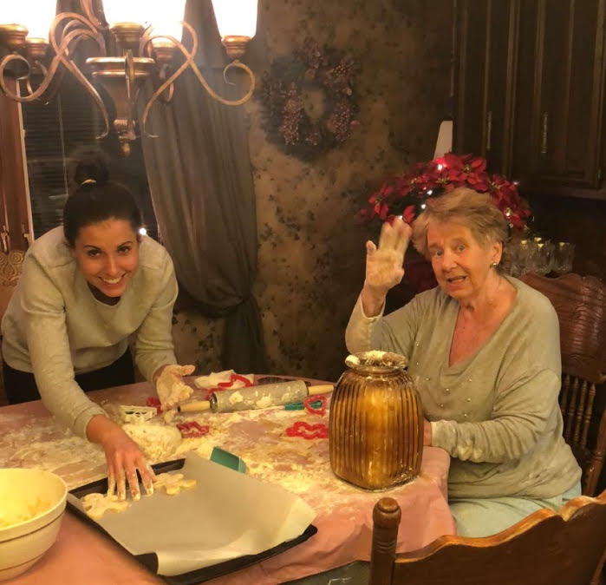

Meet Daniel:
Hi, I am Dan! I am 33 years old and work for New York State Law Enforcement. I grew up working on my family’s dairy farm and decided to become an officer after college to help serve and protect. I have a big heart and would help anyone in need. I am an outdoors guy who loves animals and working with my hands. I like playing and watching sports too, such as baseball and football. My family all lives in the country where I grew up. My greatest memories are those with my family at my grandma’s house, swimming in the pond, fishing, playing volleyball and sitting by the bonfire roasting marshmallows! I cannot wait to take my son or daughter to grandma’s house to enjoy the simple things in life. Bri, Boone and I try to go to grandmas as much as we can in the summer months to continue these traditions. Taking care of my family is my number one priority in life. My family and my faith are forever. I cannot wait to become a dad and watch our family grow through adoption. I want to teach my child the importance of having manners, working hard and to always be true to yourself.
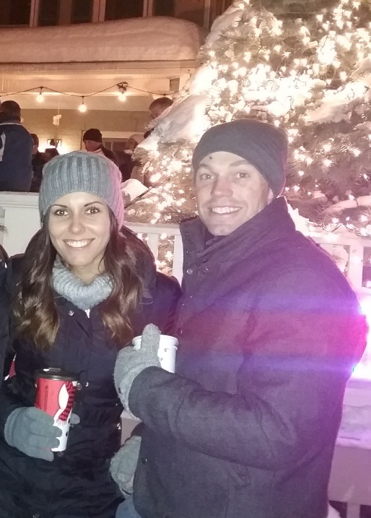
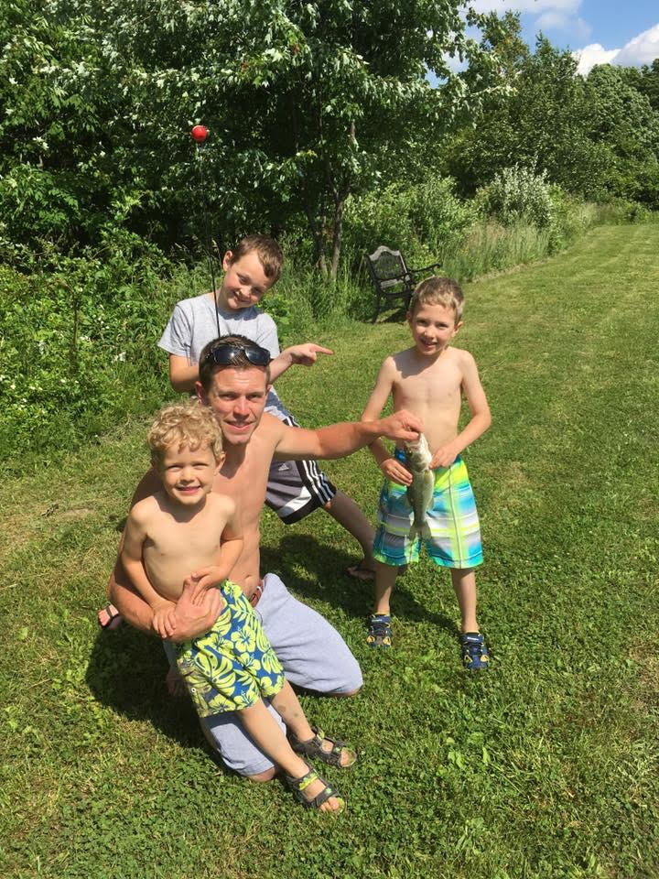
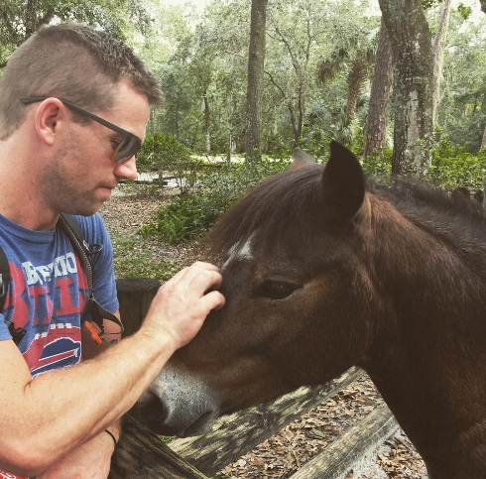

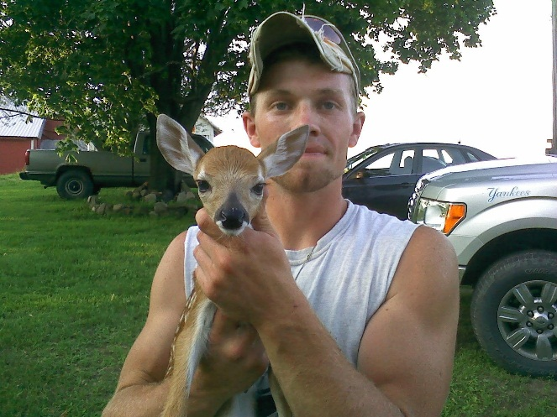
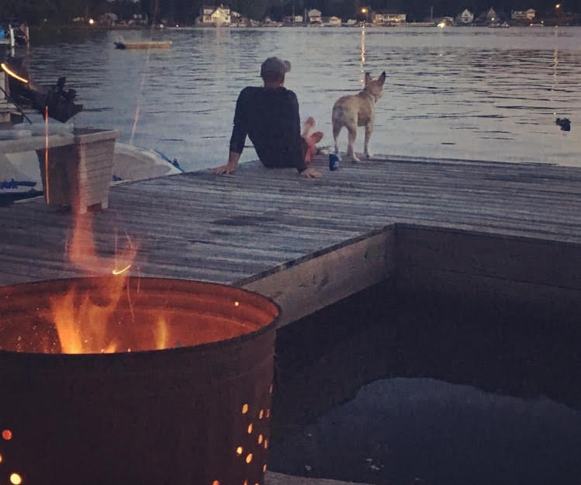

Our Home:
When we first got married, we bought a rental property in the suburbs and leased the top apartment while living in the first floor apartment. We worked together to renovate the house little by little while saving money for our forever home. About 3 years ago, we purchased a plot of land in a semi-rural area just outside of the suburbs with the hopes of one day, building our forever home. We spent almost every weekend clearing trees and prepping the land to build. Dan’s older brother builds homes for a living so the two of them worked together to construct our house. Our home is about 2,500 square feet with a large eat in country kitchen, a great room, 3 bathrooms, 4 bedrooms, and a covered back patio. It was important to us to make sure we had enough space for grandma and grandpa to sleepover whenever they want, and to host our family and friends for holidays, birthday parties, movie nights, bonfires, family board game nights and more! Our families will take any excuse to get together and we love it! We have plans to build a small barn next spring with a few chickens, goats and a horse! Dan says he loved growing up on the farm and wants our children to be able to share that same joy. Bri has always dreamed of having a horse and Dan promised, one day this would come true. Our home is very child friendly and safe. We have a designated playroom along with a nursery. All our cupboards and electrical outlets are baby proofed. The stairs have baby gates and we will always be alongside the baby while inside or out! We are fortunate enough that the baby will not have to spend time in day care either. Dan’s job allows time off during the week days and Bri’s job follows the school schedule. She is home from work by 3pm daily and off all summer and holidays! If there is a circumstance where one of us cannot be with the baby for a short time, both sets of grandparents and Bri’s sister, will be eagerly waiting an opportunity to babysit!
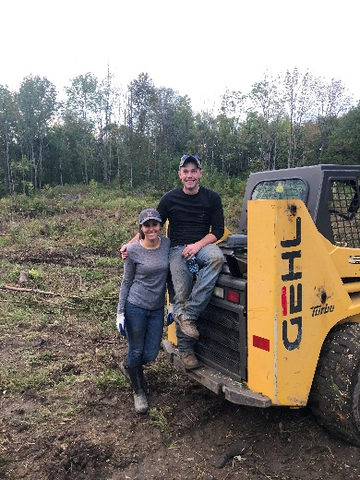

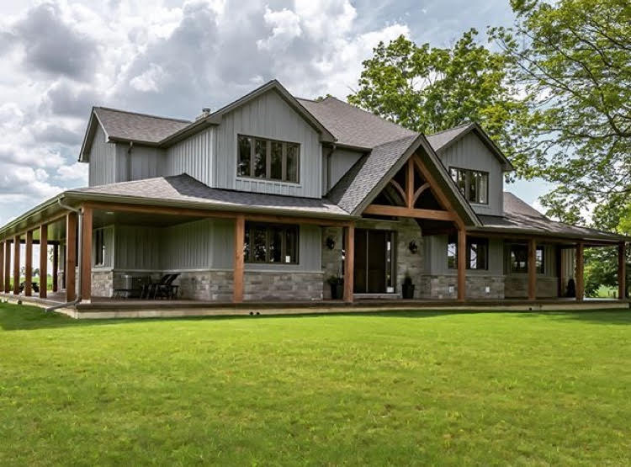

Our Faith, Family & Traditions:
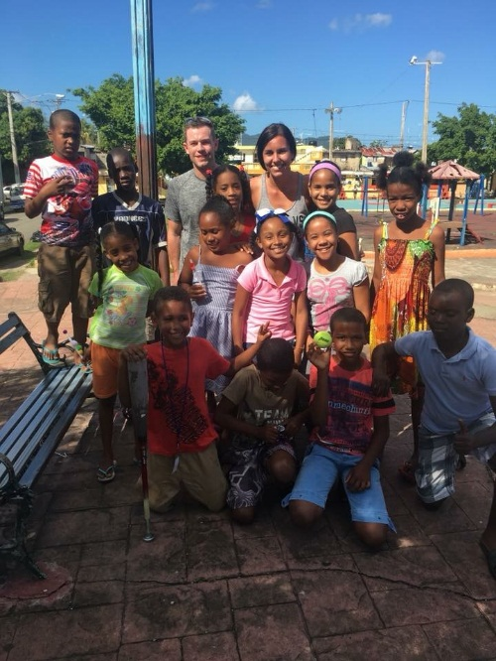
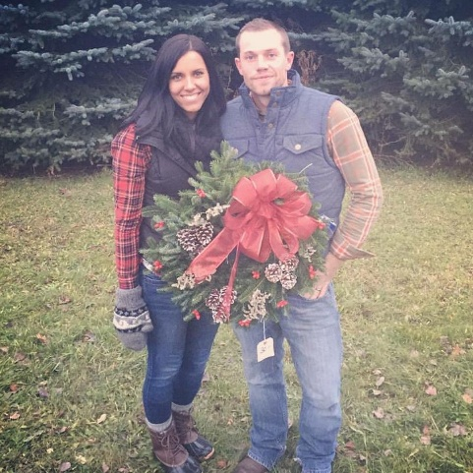
We come from very loving and supportive families of faith. We both have large families who love spending time together and also share a love for Jesus Christ! Dan is one of four siblings with four nephews and Bri has a younger sister with no children yet! Bri’s sister (Chelsea) and her husband cannot wait to become an aunt and uncle for the first time. Chelsea already refers to herself as “Aunt Chi Chi” haha. Both of our families are so supportive of our adoption plan and cannot wait to welcome to newest member to the family. We love our church and attend service weekly, we pray often and always give thanks for all we have been blessed with. After church on Sundays, we usually spend the day at Bri’s parent’s house, watching football or swimming in the pool and enjoying a delicious home cooked meal. We celebrate all major holidays including Christmas and Christmas Eve, Thanksgiving, Easter, Independence Day and so on! We spend Christmas Eve at Bri’s parent’s house and Christmas Day at Dan’s parents’ house! Now that we have our new home, we will be starting a new tradition this year and will be hosting Thanksgiving at our house! We cannot wait to have our parents, grandparents, siblings and nephews over to share a meal and remember all that we are thankful for. Easter is one of our favorite holidays spent at church and Dan’s grandma’s property… grandma plans a big Easter egg hunt for all of the grandchildren and great grandchildren! Both of our families love spending Independence Day at the cottage at the lake. We have so much fun swimming in the lake and watching the fireworks come night fall. We adore our families and couldn’t imagine life without them. Our family and faith is very important to us. We are so excited to become parents and begin new traditions with the newest member of our family!
