All our dreams can come true, if we have the courage to pursue them.

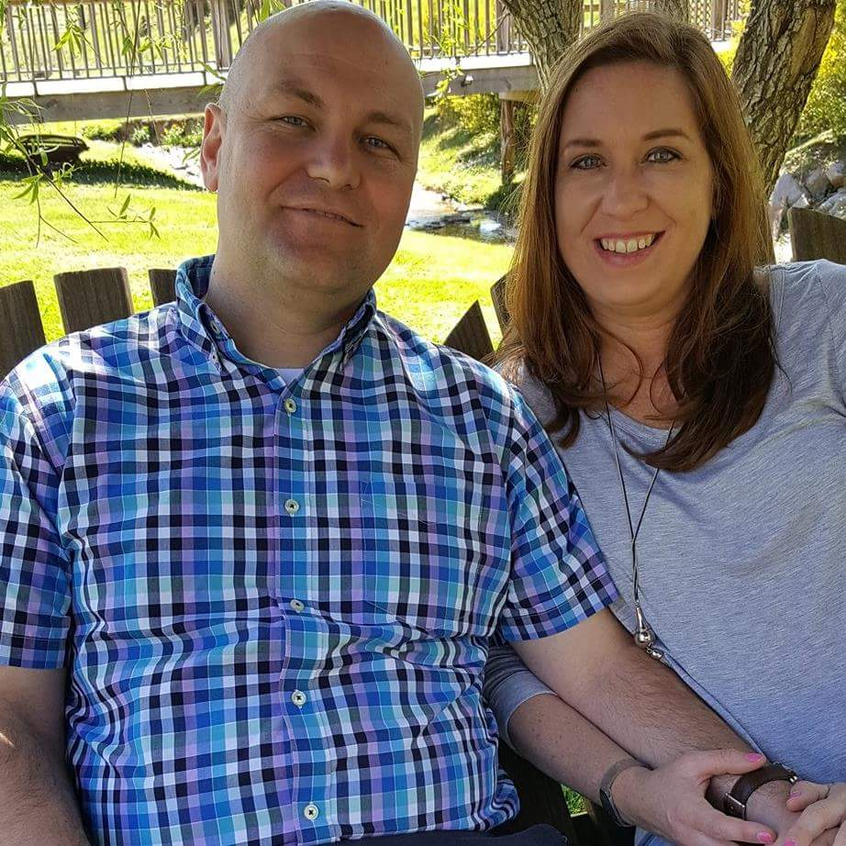

Hi! We are Casey and Tanya Landis from Murfreesboro, Tennessee! We are a loving couple who likes to laugh and have fun together. It is our dream to adopt a newborn baby. We couldn’t be any more excited about our adoption journey! We are two theme park enthusiasts who believe in spreading “Disney magic” everyday! We don’t have any kids in our home (yet!) - only one sweet and fluffy calico cat. We have a large extended family with lots of kids and several ready and willing babysitters (yay!). We love spending time together. If you like to eat birthday cake (who doesn’t), there are plenty of birthday parties. We also enjoy traveling to the beach and mountains (when we are not at the theme parks, of course), hiking, biking, gardening, and enjoying the outdoors. We are a unique family. If we can dream it, we will do it!
Our dream to adopt a child would not be possible without you. We praise you for your courageous decision. We know that this must be difficult for you. We want to provide the best possible home for your child. We would prefer a baby girl (our very own Princess) but would consider a baby boy (our Prince Charming). Even though we live in Tennessee, we are ready and willing to adopt a newborn baby from any state. We pledge to be entirely transparent. We believe that honesty and integrity are crucial for a healthy adoption. We will honor your preferences for either an open or closed adoption. If you are interested in placing your child with us, then we encourage you to contact us by phone or text at 615-542-1981 or by email at caseyandtanya@outlook.com. Please take some time to browse our site and learn more about us. Thank you! We look forward to working with you!

Casey & Tanya
Phone or Text : (615) 542-1981
Email : caseyandtanya@outlook.com
Dear Brave Mom,
I want to give you the comfort and peace of mind in knowing that your child will be loved like no other! He or she will always know the miracle of adoption and will be loved liked no other. I realize the courageous sacrifice you have made for this child and will forever be thankful for you. Children are gifts from God. It is my desire to become the best Christian mother and wife that I can be with the Lord’s help. My parents are ready to become grandparents. We also have lots of friends and family who cannot wait to welcome a child into the family. My dreams for this child are to grow and prosper and to live out their own dreams. We are open to a relationship that is comfortable for all. This child will again know the love her mother has for him or her. Love and laughter will always be at the heart of our home.
~ Tanya

Dear Courageous Mom,
I want to sincerely thank you for your courageous decision to place your child for adoption! I know that this is a very challenging time in your life, but I want to assure you that God has great plans for you and your child. It would be an honor to be entrusted with your child according to God’s plan for your life. It is my desire to become the best Christian father and husband that I can be. You can rest assured that your child will be surrounded by many family members and friends who all love them.
~ Casey

Our Story :
We met 6 years ago through my older brother and a mutual friend. They had worked with Casey for a few years. My brother mentioned to me several times that he thought our personalities and values were similar, and we would be a great match. I later learned that he told Casey the same thing. We dated for three years before marrying in a small wedding in Woodbury, Tennessee surrounded by family and close friends. Adoption has been a big part of our adult lives and has touched our hearts in so many ways. We have several friends who have adopted children, and I have a first cousin who adopted a little boy from Guatemala 13 years ago.
~ Tanya
Our Home :
We live in a quiet, kid-friendly neighborhood in the St. Andrews Community in beautiful west Murfreesboro. Our home was custom built in 2016 by Ole South Properties. It has 2,100 square feet with 3 bedrooms, 3 baths, a nice screened-in porch, fenced in yard, and a large bonus room upstairs that would be perfect as a play area. We love the outdoors so a beautiful yard was important to both of us when picking the lot for our home. Our home is conveniently located near several schools, daycares, onsite parks and playgrounds, and just minutes from a large outdoor mall and many great restaurants. We are located about 30 miles from Nashville, the heart of country music and home of the Nashville Sounds, Tennessee Titans, and Nashville Predators.
Murfreesboro is an exciting place to live and offers one of the best school districts in the State of Tennessee. It has been named one of the "Best Places to Raise Your Kids” and is one of the fastest growing cities in the state. The schools in the area are Cason Lane Academy, Scales Elementary School, Rockvale Middle School, and Blackman High School. We regularly attend two wonderful churches, Salem Creek Church of Christ and World Outreach Church, just around the corner from us. We are proud to call Murfreesboro home!
About Casey
Casey is a very loving and supportive husband. I am very blessed to have him in my life. Casey is a computer technician today but used to be a high school teacher. He is a huge fan of the Chicago Cubs and enjoys watching his alma mater University of Tennessee football and basketball teams. Some of his favorite memories is catching a baseball at a Cubs game, eating at the famous Harry Carey restaurant, and seeing his beloved Cubbies win the World Series in 2016. Casey also enjoys reading, especially Disney books about the theme parks. His favorite season is summer and he loves spending time outside biking, swimming, and hiking. When he was a high school and college student, he spent time working at an after-school program with elementary and middle school students. Casey loves entertaining kids! Playing kickball and UNO were his favorite activities with the kids in the after-school program. His father is a retired middle school and high school principal and his mother taught second grade for over 30 years. His parents now enjoy splitting their time babysitting his two nieces in Tennessee and California. They cannot wait to welcome another niece or nephew into the family.
Casey and his family members love all things Disney and going on family vacations. Casey went to Disney World many times with his family throughout his childhood and still enjoys going today. These trips became some of his most treasured memories. His family is excited about the possibility of welcoming another young child into our Disney family. Besides Disney, his family enjoys traveling to the western United States, especially by train. His favorite states to travel to are Colorado and Alaska. He loves the mountains and the beaches. In Alaska, his best memory is climbing on the top of the Mendenhall Glacier and seeing whales jumping out of the water right beside the boat in Juneau! I believe that Casey would be an awesome father. He would be attentive, loving, and supportive of a child. He would be greatly honored if given the opportunity to welcome a child in his life!
~ Tanya
About Tanya
Tanya is a fun loving, supportive wife and a true joy to be around! She is hilarious and loves to keep everyone around her entertained. She is a licensed practical nurse and has been in the nursing field for over 20 years. When you are sick or under the weather, she knows how to get you back on your feet in no time! She is an awesome mother and caretaker to our sweet and fluffy cat, Scruffy. I consider Tanya to be “the Queen of Organization” around the house. Her superpower is being able to tell you where any misplaced item is located around the house and keeping everything running with amazing efficiency. She has an enormous heart for people, especially kids, and loves planning birthday parties.
Tanya has a very large extended family who are all very close. If she is not planning the birthday party of your dreams, then she is usually attending someone else’s in the family. Some of the more popular birthday theme parties that Tanya has planned were the Mickey and Minnie’s Hawaiian Luau, Chicago Cubs baseball, the Chicken Salad Chick, and the Royal Garden. When she is not planning birthday parties, Tanya enjoys shopping for clothes and working around the yard. She loves to get her nails done but, at the same time, she is not afraid to get her hands dirty working in the yard and tending to the plants in her garden. She also enjoys riding her bike around the neighborhood and local parks, hiking, swimming, and decorating the house. Tanya also loves all things Disney and looks forward to the family vacations to Disney World and Disneyland. Her favorite character is Minnie Mouse and loves collecting anything with Minnie Mouse on it. Tanya cannot wait to introduce her newest family member to her favorite character and welcome a little one into our lives.
~ Casey

